**Pseudo-elements**

A CSS pseudo-element is a keyword added to a selector that lets you style a specific part of the selected element(s). For example, ::first-line can be used to change the font of the first line of a paragraph.

A pseudo-element is like adding or targeting an extra element without having to add more HTML. They have a variety of roles and you can learn about them in this module.

Syntax

selector::pseudo-element {

property: value;

}

**example**:

hamburger menue in css using pseudo-elements

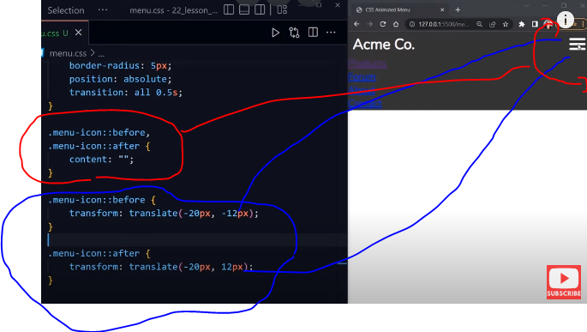

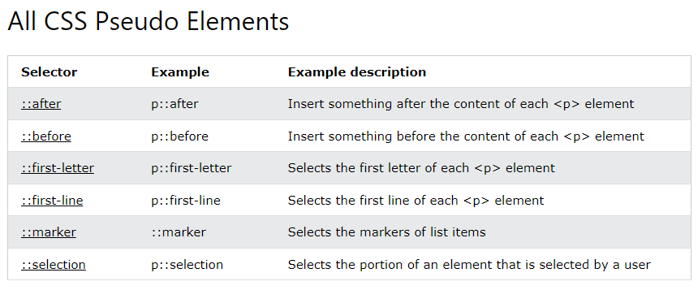

The following properties apply to the ::first-letter pseudo- element:

* font properties
* color properties
* background properties
* margin properties
* padding properties
* border properties
* text-decoration
* vertical-align (only if "float" is "none")
* text-transform
* line-height
* float
* clear

example:

p::first-letter {  
  color: #ff0000;  
  font-size: xx-large;  
}

p.intro::first-letter {  
  color: #ff0000;  
  font-size: 200%;  
}

p::first-letter {  
  color: #ff0000;  
  font-size: xx-large;  
}  
  
p::first-line {  
  color: #0000ff;  
  font-variant: small-caps;  
}

Alphabetical index

Pseudo-elements defined by a set of CSS specifications include the following:

1. A

::after

1. B

::backdrop

::before

1. C

::cue

::cue-region

1. F

::first-letter

::first-line

::file-selector-button

1. G

::grammar-error Experimental

1. M

::marker

1. P

::part()

::placeholder

1. S

::selection

::slotted()

::spelling-error Experimental

1. T

::target-text

